Project Design Phase-II Technology Stack (Architecture & Stack)
Date | 4 Feb 2026
Team ID | LTVIP2026TMIDS60231
Project Name | ToyCraft Tales: Tableau's Vision into Toy Manufacturer Data
Maximum Marks | 4 Marks
Technical Architecture:

"ToyCraft Tales: Tableau’s Vision into Toy Manufacturer Data"
Example: Data-Driven BI System for Toy Manufacturer using Tableau
Scenario: A toy manufacturing company wants to visualize its production efficiency, inventory turnover, and sales performance using Tableau dashboards. The system integrates data from ERP, CRM, and supply chain sources and delivers actionable insights to stakeholders.

A toy manufacturing company wants to track and visualize:

* Production Efficiency

*Inventory Turnover

*Sales Performance

using Tableau dashboards. The system integrates data from multiple business systems (ERP, CRM, SCM) and delivers real-time, actionable insights to managers and analysts
Based on IBM Reference:

https://developer.ibm.com/patterns/ai-powered-backend-system-for-order-processing-during-pandemics/

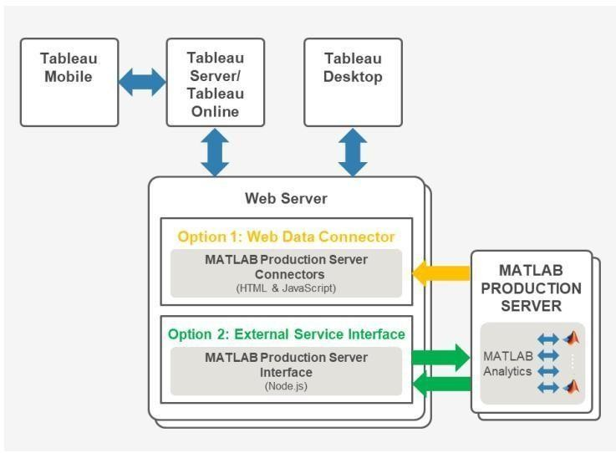

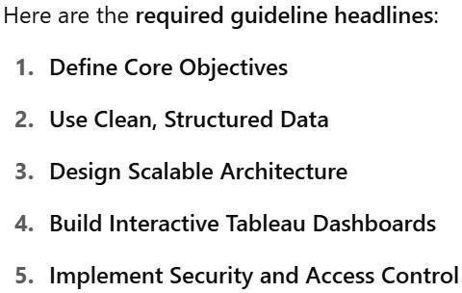
Table 1:Components and Technologies

S.no | Component | Description | Technology
1 | User Interface | interactive dashboards for Sales, Inventory, and Production Analytics | Server/Online
2. | Application Logic-1 | Python logic to clean, transform and enrich toy manufacturing data | Python (Pandas, NumPy)
3. | Application Logic-2 | (Optional) STT for voice-enabled dashboard access | IBM Watson STT API
4. | Application Logic-3 | (Optional) Chatbot to assist users in querying data in natural language | IBM Watson Assistant
5. | Database | Structured operational DB for internal use | PostgreSQL / MySQL
6. | Cloud Database | Scalable cloud data warehouse for analytics and dashboard feeding | Snowflake / Amazon Redshift
7. | File Storage | Storage for Excel/CSV raw files from sales or supplier feeds | AWS S3 / Google Cloud Storage
8. | External API-1 | Weather data to correlate toy sales trends with climate | IBM Weather API / OpenWeatherMap
9. | External API-2 | Verify vendor or distributor details through national ID integration | Aadhar API (or simulated)
10. | Machine Learning Model | Predict toy demand, seasonal patterns, and return risk | Scikit-learn / TensorFlow.
11 | Infrastructure | Tableau and data pipeline deployment on cloud | AWS EC2, Docker, Kubernetes, Tableau Online

Table-2: Application Characteristics:

S.No | Characteristics | Description | Technology
1. | Open-Source Frameworks Used | for ETL, ML, and data ingestion Python, Flask | , Apache Airflow, DBT
2. | Security Implementations IAM ro | les, RLS in Tableau, encryption for data SHA-2 | 56, SSL, OAuth 2.0, Tableau Security
3. | Scalable Architecture Microservice  Tableau Online | s and 3-tier model used for Docker, REST APIs, | Snowflake, modular deployment
4. | Availability Load-balanced cloud dep | loyment ensures AWS Load Balancer, Multi  high uptime) | -zone  Tableau Server
5. | performance Tableau extracts, in | -memory caching, Tableau Hyper Extracts, Re | dis, AWS optimized queries, and
CDN usage CloudFront

References:
*IBM Architecture Reference: https://developer.ibm.com/patterns/online-order-processing-system-during-pandemic/ *C4

Architecture: https://c4model.com/

*AWS Architecture: https://aws.amazon.com/architecture

